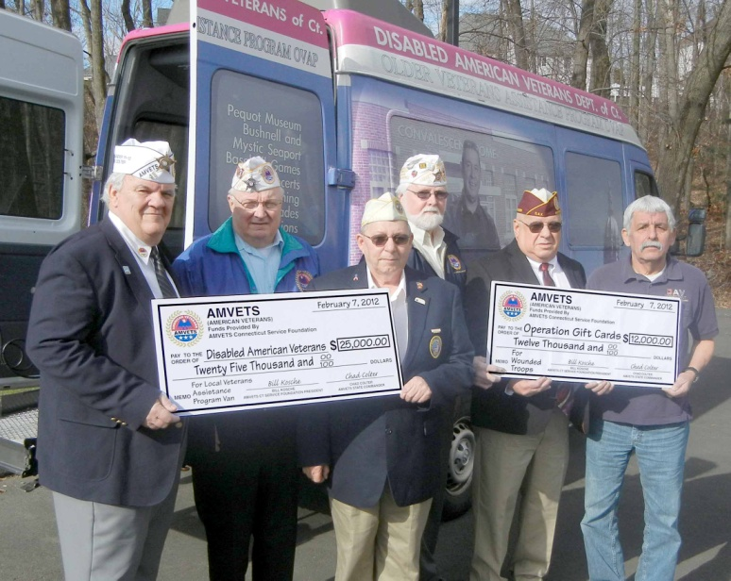

The Connecticut AMVETS recently donated two checks to The Dept of CT Disabled American Veterans in the amount of $37000.00. $12000.00 is for Operation Gift Card and $25000.00 toward the purchase of a LVAP Van. In picture from left to right is Chad Colter State Commander AMVETS, Bill Kosche AMVETS Service Foundation Pres. , John Carbone State Commander DAV, Doug Newell AMVETS State Financial Officer, Al Church State Treasurer DAV, and Rich Pescatore State Adjutant DAV.

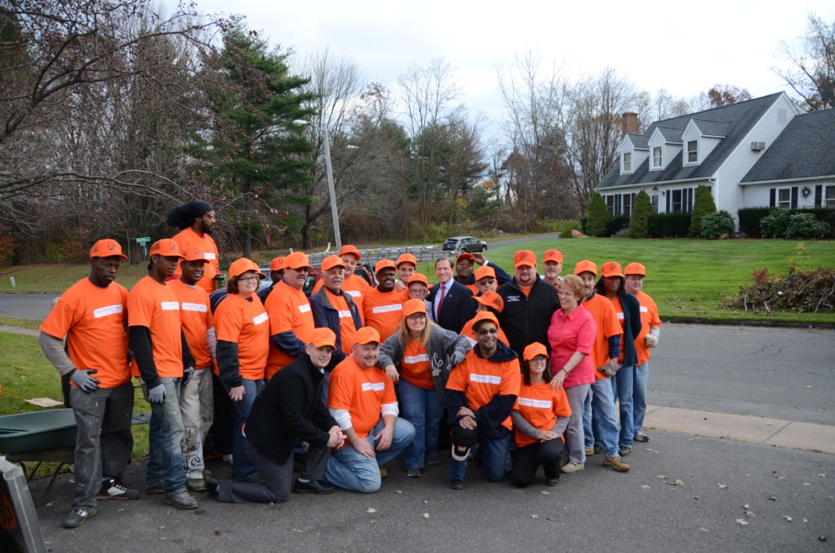

On Nov 11th the Dept of CT DAV with cooperation of Home Depot and the Bloomfield Contractors Association installed new windows and doors at the house of Joe Price member of Chapter 47. The project was done through the Home Depot Foundation. The DAV was represented by state officers and members of Chapter 47. Also in attendance was U.S. Senator Richard Blumenthal. The Coordinator for Home Depot was Rev. Ben Dowdell.

The annual Christmas in February was held on February 15th at the Rocky Hill Veterans Home gifts were givens approximately 80 veterans. Commander John Carbone would like to thank members of Chapter 5, 7, 8, 10, 47, and 52 for their participation and donations.