
DISABLED AMERICAN VETERANS
DEPARTMENT OF GEORGIA
NEWS LETTER
4462 Houston Ave. Macon Ga. 31206
Cell: 478-972-5024 Fax: 478-788-2934

PHONE: 478-781-7336 EMAIL:gadavdept@gmail.com AUGUST 2011

From the Commander’s Desk
Emanuwel J. Dixon
DAV Dept. Commander
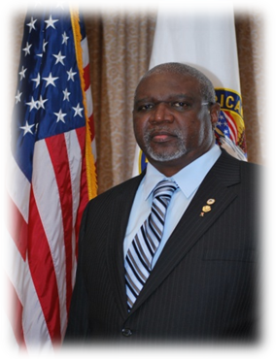

Comrades as this newsletter reaches you, we have finished a couple of major events, the C & A and the 90th National Convention! Our Newly elected National Commander is Donald L. Samuels. Congratulations to Commander Donald L. Samuels.
Both events were informative and thought - provoking ; reminding me how far we have come as well as far we have yet to go. Our Fall Conference will be held on October 21-23, 2011 at the Marriott, Macon City Center in Macon Georgia. Those of us who have far to travel may check in on October 20th, 2011 at the same discounted price. Please see the attached registration form.

Chapter Commanders take time out now to get in your Annual Financial Reports which are due
September 30th 2011. Also, check and make sure you submit your annual 990-N through the IRS website by November 2011. Adjutant Harriet Staten will get with each chapter individually on issues regarding the chapter’s monthly reports.
Since the 2011 C&A and State Convention, we have made great strides in properly preparing for the department’s annual success! The Department Executive Committee has submitted and received approval on our Constitution and Bylaws; which you will be receiving shortly. We have also submitted an application to Columbia Trust for the support of our Transportation Network System and Hospital Service Coordinators. Our Fundraiser request letter was submitted as well and since approved by our National Adjutant Arthur Wilson. Also, the Department’s Annual Financial Report was submitted with some discrepancies, but since was corrected and accepted.
The next phase of this FY is to come up with a plan of action to carry out both the Annual Motorcycle Rally and the Golf Tournament. We will be discussing some plans in our next DEC meeting, so officers come in with some detailed strategies.
My motto: “Service Those Who Have Served.” Thank you for the trust and confidence you have placed in me as your commander for the coming year. I am proud to serve our cause. I salute you!

v/r
Emanuwel J. Dixon
Commander, Disabled American Veterans
Dept. of Georgia, Inc.
478-955-4104
“ Servicing Those Who Have Served “

From the Adjutant’s Desk
Harriet L. Staten
DAV Department Adjutant

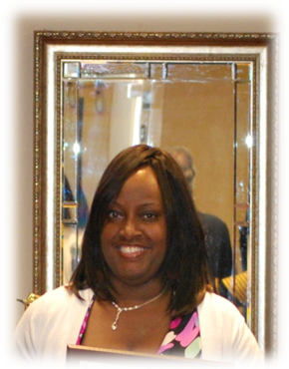
Greetings to all Georgia DAV comrades, we have completed another great year within the state of Georgia under the capable leadership of PDC Michael P. Dover.
The State Convention was a huge success, with a very nice turn out from our members. PDC Dover has passed the torch to Commander Emanuwel J. Dixon, who will continue to move the department and the state of Georgia DAV forward as he ascribes to the goals and missions of the DAV. With the year off and running, Commander Dixon, Senior Vice Martin, and myself attended the 14th annual State Commander’s and Adjutant’s Association Seminar.

A special thank you to all members who attended the National Convention! As always the Department of Georgia was well represented.

To ensure continued communication and support, I ask Chapter Commanders and Adjutants to please ensure the department has proper contact information to reach your chapter. Additionally, please continue to submit a complete monthly report within 30 days of approval by the body. Your complete report should include at a minimum the following four (4) items: copy of the minutes signed by the Commander and Adjutant; original sign in roster; finance report signed by the Commander and Treasurer (additional finance reports as appropriate, e.g. bingo, bar, etc.); and CSO report. If your chapter needs assistance from the department in any way, please email me to make arrangements. The Commander and I will be visiting each chapter as time permits. In the mean time, feel free to contact us for any problem or assistance that may be needed.

To all DAV members please use the following contact info to reach me: gadavdept@gmail.com or 478-972-5024. Thank you in advance for your continued cooperation and support as we strive to make this year one of the best ever for the state of Georgia!

To all, thank you for all you do and for all you have done.

Harriet L. Staten
Adjutant, Department of Georgia
Disabled American Veterans
“Servicing Those Who Have Served”

From the Sr. Vice Commander Desk
Glen Martin
DAV Department Senior Vice Commander

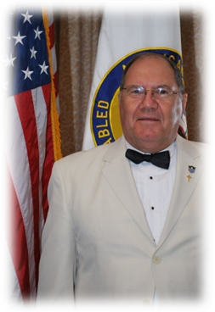
Hello Comrades,
The C&A was a valuable experience which was very well organized. The tour of Headquarter was very informative and each person’s duties were explained. Thank for having the confidence in my abilities to elect me to the position as Sr. Vice Commander and allowing me to attend the C&A. Since one of my main goals for the coming year is membership this year, that is where I spent most of my time when not in meetings. I was able to meet most people who are involved in assisting Departments and Chapters in relationship to membership. I was able to obtain a list of prospects that are veterans but not members of the DAV. This list has been or will be sent to all Chapters who have requested them this Month.

Now as a Department and Chapters we have a tool to assist us in making our Membership goals for the coming year. Georgia has the lowest Membership percentage in the US! After this year with all of us working together, we will make our goals and no longer be the lowest!

Rewards will be presented to Individuals, Chapters and Districts who sign up the most new members. Remember only full life members get counted.

If you or your Membership Chairman has any questions, call or e-mail me or go to the Membership link at www.dav.org. If using for the first time type in your Membership number, the password will be your birth date, and as always the password can be changed. If this does not work call Membership and they will help. My request will be for all chapters to send me an e-mail informing me how many new members you have signed up for the Month.

Again thanks for all you do for the Veterans in your area and Georgia.

LET US DO TOGETHER WHAT WE CAN NOT DO ALONE. If I can be of help in any area please let me know.

Glen Martin
Sr. Vice Commander
Department of Georgia Inc.
Disabled American Veterans
“Servicing Those Who Have Served”

From the Desk of the Chaplain
Chaplain Michael P. Dover
Department of Ga. Chaplain

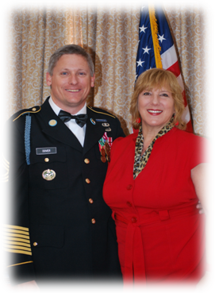
One afternoon Angela gave her young daughter four jellybeans and let her know that was all the candy she was going to receive. After practically inhaling the first three candies, Eliana lingered over the final one. She sucked on it, took it out of her mouth, bit into it, sucked on it some more, then gnawed at the outer shell.

Knowing that this was her last jellybean, she took a full 45 minutes to ingest the treat completely. Angela observed her little girl with amusement. It occurred to her that she was watching Eliana learn the value of savoring-enjoying taste and texture and learning to draw out every possible bit of flavor from the pleasurable experience.

When we read, "Oh, taste and see that the Lord is good" (Ps. 34:8), we can be sure that God wants us to "savor" His presence. He allows us to gain intimate and satisfying knowledge of Him. And when we mediate on His Word, we will draw out a deeper understanding of who He is (Ezek. 3:1-3).

As we taste His goodness and love, He will reveal the distinctive flavor of His creativity, sovereignty, holiness and faithfulness. Our Father must look on with enjoyment as we learn how to enjoy and savor Him.

*Let’s not forget to pray each day for members sick and distressed.

Please send any distressed, sickness, or deaths to the Chaplain at gadavchaplain@gmail.com or 478-781-7336.

Michael P. Dover
Chaplain, Department of Georgia Inc.
Disabled American Veterans
“Servicing Those Who Have Served”

Fall Conference 2011


Oct. 21st– Oct. 23rd, 2011 Pre-Registration

Disabled American Veterans Dept. of GA
“Building better lives for America’s Disabled Veterans and their families.”

Marriott, Macon City Center, Macon, GA

Reservations (Cut-Off 9/27/2011) 478-621-5300

NAME & TITLE to appear on badge. (Please print or type) Separate form for each attendee.

If you have a badge, please state no badge.
Name
Chapter#, City- State
Auxiliary Unit#, City-State
Telephone (home)
E-Mail

Pre-Registration must be received by October 14, 2011
AFTER October 14, 2011 ALL REGISTRAION FEES ARE $60.00 FOR FULL REGISTRATION OR $30.00 FOR MEETINGS AND FRIDAY EVENING HOSPITALITY SUITE.

Please check one box
I will be attending the 2011 Fall Conference @ $55.00 for pre-registration. This will include fee for registration, admission to all events,
Hospitality suite and Friday banquet.

SATURDAY BANQUET SELECTION (check only one): Chicken_________ Beef________ Vegetable_______

I will be bringing a Guest @ $35.00 to the Conference Banquet (Please fill out a separate form for your guest.)
I only plan to attend the 2011 Fall Conference Meetings and Hospitality Suite. @ $20.00

Acknowledgement Information
I understand that should an emergency arise and I am unable to attend to provide notice in writing to the Department Headquarters before October 14, 2011 all advance registration will be refunded. No refund will be given within 48 hours of the event or after the event. I also release the DAV Dept. of GA of any and all liability should I choose to consume alcohol at the conference.
This is confirmed by my signature below.
Signature(s)
Date
Please make checks or money order, payable to: Disabled American Veterans Department of Georgia. Please mail to:
Disabled American Veterans Dept. of GA, 4462 Houston Avenue, Macon, GA 31206

Schedule of Events

Northwest District Meeting
August 20th 2011 at 12:00 pm
100 Library Lane,
Jasper, Ga. 30143

Central District Meeting
September 10, 2011 at 11:00 am
4493 Houston Ave (CH #9)
Macon GA. 31206

Northeast District Meeting
October 8, 2011 at 10:00 am
Oconee Memorial Park
3500 Hog Mountain Rd. (CH #92)
Watkinsville, GA 30677

State Fall Conference
October 21-23, 2011
240 Coliseum Dr.
Macon, GA 31217
478-621-5300

9th District Mid-Winter Meeting
January 20-22, 2012
Landmark Resort Hotel
1501 S. Ocean Blvd.
Myrtle Beach, SC 29577
1-800-845-0658

NEWLY ELECTED AND APPOINTED OFFICERS
FOR 2011 – 2012

Emanuwel J. Dixon ………….. Dept. Commander
Harriet L. Staten………………….Adjutant
Glenn D. Martin ………….. Sr. Vice Commander
Bobby J. Huggins ………….. 1st Jr. Vice Commander
Burt Jimmerson ………….. 2nd Jr. Vice Commander
Willie Davis Jr. …………… 3rd Jr. Vice Commander
Manny Lozano …………… Judge Advocate
Charles Weeks…………………… Inspector General
Michael P. Dover ………….. Chaplain
Clarence Sinkler………………… Assistant Chaplain
Madison Price, Sr. ………….. Treasurer
John Causey …….………. Finance Committee Chairman
Brian Wilner ……………. Finance Committee Member
Freddie Swint …………….. Finance Committee Member
Willie Atkinson ……………… Northwest District Commander
Jonathan Smalls ……………….Northeast District Commander
Ned Reese ………………. Central District Commander
Quincey L. Roberts ……………… Southwest District Commander
Cort Nordeoff ……………… Southeast District Commander
Johnny Patterson …………….. Blue Hat Chairman
Johnny Travis……………………….Chief of Staff

DEPARTMENT WEBSITE
http://www.davmembersportal.org/ga/default.aspx

“SERVICING THOSE WHO HAVE SERVED”

