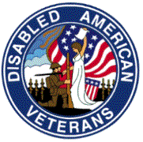
DISABLED AMERICAN VETERANS
Chapter 13
Post Office Box 639
Glen Burnie, MD 21061

___________________________________________________________________________________
Commander/Editor Aux. Commander Adjutant
Pete Schwarz Pat Schwarz Thomas Sadler
(410) 551-6760 (410) 410-760-3577
____________________________________________________________________________________________________
Chapter meetings every 1st Thursday of the month at 7:00PM, 8068 Quarterfield Road, Severn, Maryland
September 2010 – December 2010

Dear Comrades:
It was truly a hot summer this year and I hope that September will bring much cooler temperatures so that we are more comfortable while sitting outside of the Walmart store on Quaterfield Road passing out Forget-Me-Not flowers and accepting donations from shoppers and visitors. This year we are allowed to be in front of the store each Saturday and Sunday during the month of September. This means we will need a lot of help from our chapter members on each weekend. Please consider stopping by and volunteering a few hours. Contact me at 410-551-6760 if you have any questions or if you have time to be put on the collection schedule. During the first two weeks in November we will need volunteers to sit at our information desk at the Golden Corral on Ordinance Road. We could collect more donations if we could find more chapter members to accept donations at the desk. You may eat free of charge when you work there and the Golden Corral will offer free meals for all active military personnel and all veterans on November 15 between 5 and 9 PM. The Military Appreciation Monday is the Golden Corral’s way of saying “Thank You!” to our nation’s veterans and active duty military.

Our chapter mailed out more than 6,000 raffle tickets to Chapter 13 members. The chapter has presently 854 members; however, only about 25 members are active and participate in our fund raising efforts and other chapter business. Since many of you are physically unable to visit us at our meetings or are otherwise engaged it would be a great boost to our budget if you would consider showing your support by purchasing some of the tickets which were mailed to you. We could do so much more if we had sufficient funds to answer the call for help from veteran hospitals, military hospitals, veterans homes, and from individual needy veterans.

We will have our Christmas Party on December 2, 2010. As always, the bar will open at around 6 PM and dinner will be served at 7 PM. Let us know if you are planning to bring any children so that we can inform Santa Claus. Please contact
Bob Mullenax at 410-255-3730 in early November and let him know that you are coming to the party. We will need to have an exact headcount to prevent ordering too many meals from the caterer. This is a good time to meet new members and family members. Please remain connected to the chapter – life is good.

For God, Country and the DAV
- Pete

Events
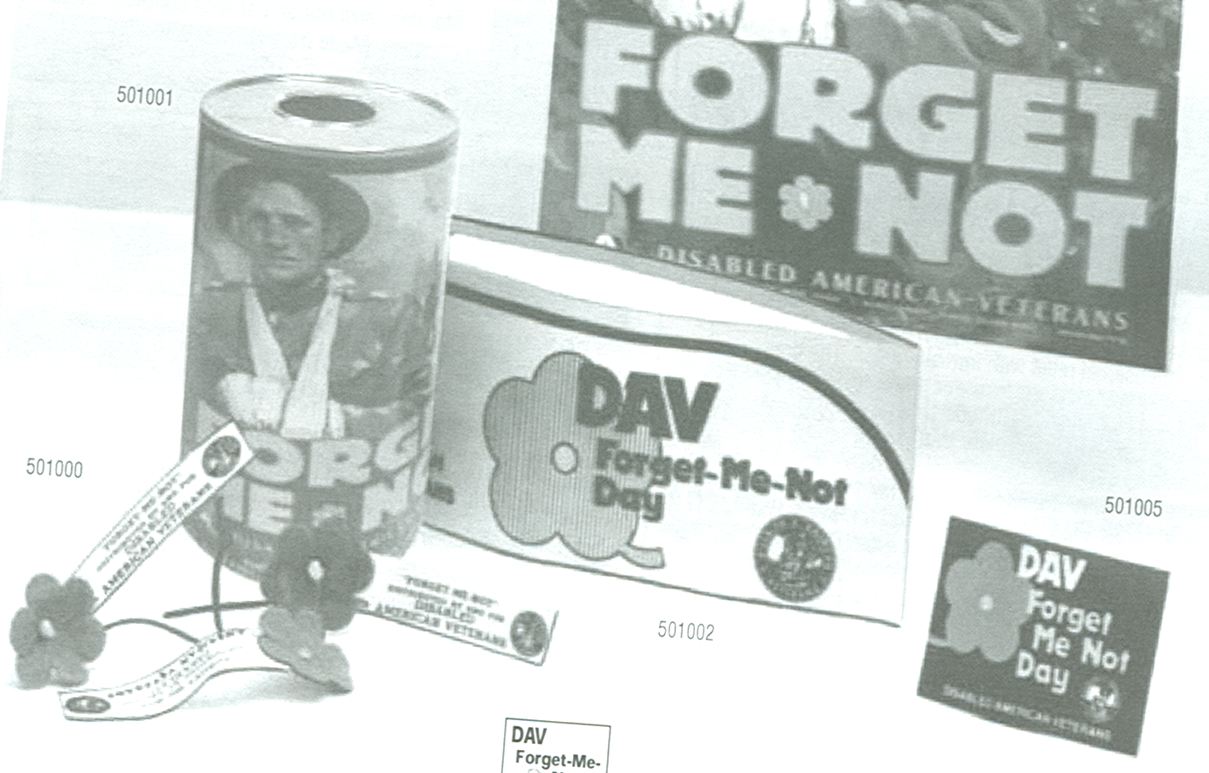
Sep. 2, 2010 General Meeting, 7:00pm
Forget-Me-Not at Walmart
(every weekend)
Sep. 23, 2010 Executive Meeting, 7:00pm
Oct. 7, 2010 General Meeting, 7:00pm
Oct. 28, 2010 Executive Meeting, 7:00pm
Nov. 4, 2010 General 7:00pm
Nov. 11, 2010 Veterans Day Ceremony
CrownsvilleVeterans Cemetery 11am
Nov. 15, 2010 Veterans Night at Golden Corral
Nov. 18, 2010 Executive Meeting 7:00pm
Dec. 2, 2010 Chapter Christmas Party
DAVA Unit Commander’s Message:

Hello,

Well, three months have passed since I had the opportunity to speak to you and we are in the heat of the summer . . . and I do mean heat with plenty more expected. We enjoyed riding in the Memorial Day Parade and also enjoyed the services at Crownsville honoring our veterans. We had a great time at the annual picnic at Fort Smallwood Park. All proceeds from the White Elephant sale went to the Auxiliary. Starting September the DAV will start collecting for the Forget-Me-Not drive at Wal*Mart on Quarterfield Road. They would really appreciate us helping them out. This is every Saturday and Sunday from 8:00 to about 4:00 or 5:00. We would take four hour shifts and work in groups of two. Then the first two weeks of November they will be collecting at the Golden Coral. Again in 4 hour shifts and groups of two. We do get a free meal each time we work there. So, please, ladies, let’s support our DAV and fill in some of those vacant spots. Then, of course, there will be our Christmas Party. We will learn more about this as the time approaches. Till next time …

United We Stand,
Pat Schwarz, DAVA Unit Commander

Service Officer Report:

The Department of Veterans Affairs (VA) has selected its regional benefits office in Providence, R.I., to test a paperless system and new procedures to improve processing of Veterans’ claims for disability compensation.
“This test program marks a major milestone in VA’s move to paperless processing,” said Secretary of Veterans Affairs Eric K. Shinseki. “It supports VA’s transformation of the claims process to ensure speedy delivery of benefits to Veterans, their families and their survivors.”
The pilot, which initially focuses on compensation benefits, is expected to start at the Providence facility in November, with completion in May 2011. Additional pilots are expected before the new claims system is deployed to all 57 VA regional benefits offices.
The Providence pilot is part of the Veterans Benefits Management System, one of more than three dozen initiatives in progress at VA to “break the back of the backlog.” This first VBMS pilot comes after completion of the Virtual Regional Office project collocated at the Baltimore Regional Office in May 2010. VA brought claims processors from around the country to Baltimore this past spring to assist in the rapid prototyping of a demonstration system. Secretary Shinseki has set a goal that by 2015 VA will process all claims within 125 days with 98 percent accuracy. VA will provide compensation, pension, education, loan guaranty, vocational rehabilitation, employment, and insurance benefits valued at nearly $70 billion this year to Veterans, their families and survivors through 57 VA regional offices.

Application for Health Benefits

As part of Secretary of Veterans Affairs Eric K. Shinseki’s effort to streamline access to benefits, the Department of Veterans Affairs (VA) has removed the signature requirement for Veterans who electronically submit an online 10-10EZ “Application for Health Benefits.”
“This singular action will reduce days, if not weeks, for Veterans who apply online to access their hard-earned medical benefits and upholds the promise to reduce access barriers to needed care for this Nation’s Veterans,” said Shinseki.
Previously, Veterans filling out the online application were required to print a copy, sign it and send to their local medical center or wait for a copy to be mailed to them for signature and mailing before enrollment into the VA healthcare system could occur.

(Department of Veterans Affairs)

Affordable Care Act
The Disabled American Veterans (DAV) is pleased that President Barack Obama’s administration has vowed that veterans and servicemembers would continue to receive prosthetic devices from the Department of Veterans Affairs or TRICARE at no cost. The White House announcement last week dispelled unfounded rumors that disabled veterans and servicemembers would face a new tax on prosthetic limbs and other vital medical services under the Affordable Care Act. While the health care law does impose a new tax on big medical device manufactures, the tax will not be passed on to veterans and servicemembers. “The President’s statement should help put to rest unfounded rumors that have been spread among our nation’s disabled veterans and servicemembers,” said DAV National Commander Roberto “Bobby” Barrera. “Our veterans and servicemembers were suddenly struck by these rumors, and many feared that our government was abandoning them to pay for their own disability.”
Prices and reimbursements for medical devices will continue to be negotiated between manufacturers and insurance companies, retail establishments and, in the case of the federal government, for veterans and servicemembers. The full cost of prosthetic devices for veterans will continue to be borne by the government. “The DAV is committed to ensuring the highest quality health care for disabled veterans and that service-connected disabilities remain the responsibility of the federal government,” said Commander Barrera. “The disabilities veterans and servicemembers have suffered as a result of their military service will affect them the rest of their lives. They have earned their government health care and benefits through sacrificing for our nation.”
(DAV National Headquarters)
Transportation Network at the Glen Burnie VA Clinic
Through the Transportation Network, DAV volunteers drive sick and disabled veterans to and from VA medical facilities for treatment. The Transportation Network is a clear example of veterans helping veterans. The DAV stepped in to meet a substantial community need when the federal government terminated its program that helped many veterans pay for transportation to VA medical facilities. The DAV has 189 Hospital Service Coordinators around the country who coordinate the transportation needs for disabled veterans. Our volunteer drivers at the Glen Burnie VA Clinic transported this year 2,610 veterans to the clinic, driving 39,630 miles and volunteering 3,377 hours. This ensures that needy veterans are able to make medical appointments on time and have transportation to their home. Tommie Hawkins and the volunteer drivers have made all this possible.

War is an ugly thing, but not the ugliest of things. The decayed and degraded state of moral and patriotic feeling which thinks that nothing is worth war is much worse. The person who has nothing for which he is willing to fight, nothing which is more important than his own personal safety, is a miserable creature and has no chance of being free unless made and kept so by the exertions of better men than himself.
John Stuart Mill (1806 - 1873)

DAV Chapter 13 has its own website! You can find it at www.dav.org or www.davmembersportal.org/chapters/md/13 POC: Pete Schwarz (webmaster)

Help us in our fund-raising effort with your donation!
DAV CHAPTER 13, GLEN BURNIE, MD

BUILDING BETTER LIVES FOR AMERICA’S DISABLED VETERANS

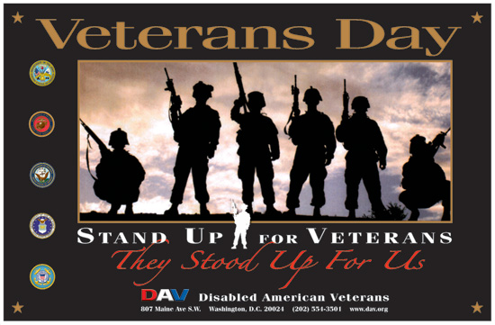
Freedom is not free!

Please become active in your local chapter of the Disabled American Veterans and tell others about it.

