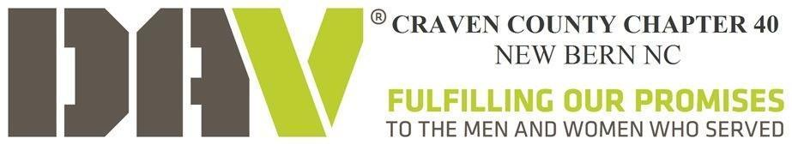

DAV Chapter 40 Minutes for 12 Decmeber 2025

1. Commander Gene Passarelli called the meeting of DAV Chapter 40 Craven County to order at 7:04 PM at Elks Lodge Post 764. Opening Prayer was led by Chaplain Karen Hacker, and Commander Passarelli led the membership in the Pledge of Allegiance. Commander Passarelli read the DAV Mission Statement.

2. Adjutant completed a Roll Call of Officers.
Present:
Commander Gene Passarelli SrVCmdr Excused JrVCmdr Guy Pascerri
Treasurer Dave Rust Chaplain Excused Adjutant Steven Douglas

In attendance there are 3 officers, 3 members and 3 guests for a total of 9. There is a quorum.

3. 10 October 2025 minutes to be approved. John Dilahunt motioned to accept minutes with approved changes and motion was seconded by Anton Roest. Discussion. Vote. Motion passed. Minutes approved.

4. Treasurer’s Report:
06 JAN 2025
Bank Balance From Sept $ 6456.29
Checks Written $ (244.98)
Deposits $ 43.00
Cash On Hand $ (100.00)
Total Bank Balance $ 6254.31

5. Sickness, Distress and Hospital Committee: Gene Pascerelli and Jane Throw (Aux) are recovering. Marie Oversbee passed buried besides husband.

6. Reports of Committees:
a. Audit - Treasurer & Audit Committee: AFR has been Approved. Audit Pending
b. Benevolent (Cmdr/Chap/Treasurer): FMN funds $ 64.40;
Benevolent funds $ 77.48
c. Bylaws (Cmdr/Adj): None
d. Chapter Service Officers: None
e. Entertainment Committee: (SrVCmdr)
f. Legislative: (Adj) All bills mentioned and copies handed out
g. Membership: (Cmdr)
h. VTN Coordinator: Phone number is (252) 638-5900
i. Veteran’s Council Craven County (VCCC): Gene Passarelli and Karen Hacker

7. Unfinished Business:

- Christmas Party
  - Special Thank you to the Chairs DAV and DAVA Dave and Melaine Rust, and Karen Hacker.
- Next Meeting February 10 and March 10, 2026 with Change of Command votes March.

New Business:

- Tonywanda Jackson HVAC replacement, Motion to allocate up to $240 to assist Veteran. Motioned by Steven Douglas, seconded by Anton Roest, Discussion, Motion Passed.
- New VA Policy dealing with rides from Uber and Lyft to Medical Care Facilities. Policy discussed.
- Future Ideas for Fund Raising, Partner up with local Establishments for a share of profits night
- DAV Department Convention Dates Changed to 21-24 March 2026, so Meeting February and March holding new elections for Change of Command in March before the Convention.
- Chairs for Events:
Bayview Chair: Vacant
Forget Me Not Chair: Vacant
CCVC Chair: Gene Pascerelli and Karen Hacker Alt Steven Douglas
- CCVC Events Posted on Facebook:
- Budget Items:
  - Bayview Bags Each $30 Birthday, $50 Christmas
  - Food Bags $375
  - Zoom $80
  - Storage $650
  - PO Box $210

8. Good of the Order:

- Completed all Christmas events and Food Drives including RCS partnership with American Legion 24.
- Bayview Visits are 1st Tuesday of every Month.
- Elk’s Lodge Rib Roast and Bingo Night at the Kinston Home for Veterans April

9. Adjournment Ceremony. At 8:18 PM, Commander Gene Passarelli devoted a minute of silence to our departed comrades. Karen Hacker ended the meeting with a prayer. The meeting adjourned at 8:20 PM. Motion to Adjourn Jody Pascaerlli and seconded by Dave Rust, discussion, Motion Passed.

10. Next meeting will be held at 6 PM on Tuesday, 09 December 2025 at the Elks Lodge 764, 1175 Pine Tree Drive, New Bern, NC.

