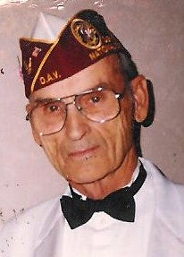Victor Carl Hass, 92, Minot formally of Bowbells, died Thursday, November 20th, 2014 in his home. Victor was born February 23, 1922 in Minnesota Township near Bowbells ND to Albert A. and Olena (Eide) Hass. Victor joined the Navy in February 1944 and served in the South Pacific Theater during WWII. He was awarded the Purple Heart for wounds he received during the Battle of Okinawa. Victor was discharged from the service in January 1946 and to continue caring for and being with veterans he joined the American Legion Post #127 in his home town of Bowbells serving as Commander and was the Adjutant for many years.

Victor joined the Disabled American Veterans in 1969. He was active in the Disabled American Veterans throughout the years. He was Commander of the Minot Chapter #4, North Dakota Department Chaplain, North Dakota Department Commander in 1986-87 and NEC of District 14 in 1995-96. He was a founding member of the North Dakota Veterans Home Foundation Lisbon ND and received 3 year appointments on the North Dakota Administrative Committee on Veterans Affairs by both Governor Sinner and Governor Schafer.

He was a life member of the Disabled American Veterans, Trench Rats holding National Office for 2 years, American Legion, 40&8, Military Order of the Purple Heart, VFW, Amvets and International War Veterans Alliance.

Those who shared in his life Wife of 70 years Margaret, Son Lonnie D Hass, Daughters Vickie Carla Heisler and Melanie Jeni Kuhn, 7 Grandchildren and 8 Great-Grandchildren.