Our Congressional Team

All too often I hear citizens in general and veterans, in particular, discuss their concerns about what is happening in our country. Too often they are not aware that our congressional team is there to assist them with the challenges whether they are large or small. Thus, Information on our congressional team is provided to assist you in obtaining assistance on items or issues of concern to you.

There are things you must consider when you finally make the decision to discuss a concern. Remember, when contacting a member of their team, it may be best to start with the office closest to you. The aides are generally idealistic and very conscientious troops - many are college graduates - who are willing to do their best to assist you. Make some reminders or notes so you remember what you want to tell them or ask them. After you finish, you might want to send your notes to the individual with whom you spoke. This insures that you are both on the same page.

If you chose to write or send an email, it is always a good idea to start off with a subject line so they know just what your issue or concern is. Then tell them the reasons why you favor or dislike the issue or concern. When writing, I recommend you write the missive and then let it sit for a day or at least overnight. Then come back and read it again. It’s amazing how often we say, “Did I really say that?” Remember, the length of the article is not the best argument. It is the thought and the facts to support your argument that are important.

Keep in mind, each congressional team member represents you and wants to hear from you when they are making important decisions. They need to know where you, as one of their constituents, stand and what you want them to know. So tell them!

If you have access to a computer, it is easier to get an email through as opposed to a letter. Letters have to go through a certain amount of scrutiny, and certain delays are built into the process, to make sure someone isn’t sending something that can harm the congress person or their staff. This can delay receipt. Send it to the closest office and they will put it in a packet to be delivered to their respective staff members.

Hope this information will help you in making your point or help you to achieve learning more about your concern. Just remember specific facts usually get the most attention, especially if they are concise and clearly written.

Keep in mind, if you are concerned; then get the message out!

Good Luck!

Senator
Jeanne Shaheen, (D)

Senator Jeanne Shaheen has dedicated her life to serving New Hampshire families. Through her work as a teacher and later working at all levels of government, Shaheen has proven that her first priority is the well-being of our state and its proud citizens. After teaching, chairing the Madbury zoning board, and serving three terms in the State Senate, Shaheen became the first woman in New Hampshire history to be elected Governor, serving three terms from 1997-2003. Continuing her commitment to investing in our nation’s next generation, Shaheen became the Director of Harvard University’s Institute of Politics at the Kennedy School of Government in 2005. After a triumphant victory in one the most watched Senate races in the U.S., Shaheen was sworn in as a member of the U.S. Senate in January 2009.

Committee Assignments:

Senate Foreign Relations Committee
Subcommittee on European Affairs (Chair)
Subcommittee on African Affairs
Subcommittee on International development and foreign assistance,
economic affairs and international environmental protection
Subcommittee on International organizations and operations, human
rights, democracy and global women’s issues

Committee on Energy and Natural Resources
Sub-Committee on Water and Power (Chair)
Sub-committee on Energy
Sub-Committee on Public Lands and Forests

Committee on Small Business and Entrepreneurship

Senate Armed Services Committee
Sub-Committee on Emerging Threats and capabilities
Sub-Committee on Readiness and Management Support
Sub-Committee on Strategic Forces

Through her work in the Senate, Shaheen continues to effect positive change for all Americans.
Office:
Washington, D.C. Office:
520 Hart Senate Office Building
Washington, D.C. 20510
202-224-2841
202-228-3194 fax

Local offices:

Manchester, NH Office:
1589 Elm Street Suite 3
Manchester, NH 03101
603-647-7500
603-647-9352 fax

Dover, NH Office: Contact: Sarah Holmes, Special Assistant
340 Central Avenue, Suite 205 for Policy and Projects
Dover, NH 03820 Veterans and Defense Issues
603-750-3004 sarah_holmes@shaheen.senate.gov
603-750-4046 fax 603-750-3004

Berlin, NH Office: Claremont Office
961 Main Street 50 Opera House Sq.
Berlin, NH 03570 Claremont, NH 03743
603-752-6300 603-542-4872
603-752-6302 fax 603-542-6582

Nashua, NH Office:
60 Main Street
Nashua, NH 03060
603-883-0489
603-883-0196 fax

Kelly A. Ayotte
United States Senator (R)
Kelly Ayotte is a New Hampshire native who has devoted her life to public service.
Born in Nashua, Kelly attended public schools there. She graduated with honors in 1990 from Pennsylvania State University and earned a Juris Doctor degree in 1993 from the Villanova University School of Law. After completing her legal education, Kelly returned to New Hampshire and served for one year as a law clerk to state Supreme Court Associate Justice Sherman Horton (now retired). She is married to Joe Daley, a Nashua native who flew combat missions during the Iraq war and currently serves as a Lieutenant Colonel in the Air National Guard. She helped him launch a landscaping and snow removal company, which provides her with a firsthand understanding of how decisions made in Washington impact small businesses.
A prosecutor at heart, Kelly was the first woman to serve as the state's Attorney General. Appointed to that position in 2004 by a Republican governor, she was twice reappointed by a Democrat governor. In her first bid for public office, she was elected to the U.S. Senate in 2010 with 60 percent of the vote. In the Senate, Kelly serves on the Armed Services, Budget, Commerce, and Small Business Committees. She is the Ranking Member - top Republican - on the Armed Services Subcommittee on Readiness and Management Support.
As the wife of a veteran, Kelly understands the profound sacrifices of those who have risked their lives in service to our country. One of the happiest days of her life was when her husband Joe, who flew combat missions in the A-10 Warthog, returned home from the Iraq War. She is also especially proud to be the granddaughter of a World War II veteran.
From that personal perspective, Kelly recognizes the importance of ensuring that America's veterans receive the support and care that they've earned. New Hampshire, which has a large veteran population, is effectively the only state in the nation without a full-service VA hospital - forcing many Granite State veterans to travel long distances and cross state lines to receive treatment. Kelly is working in a bipartisan way to ensure that New Hampshire veterans don't have to travel outside the state to access full-service VA care.
Additionally, Kelly's office is a resource for those who have served in our nation's military - standing ready to assist New Hampshire veterans and their families.

Committees:

Armed Services
- Ranking Member, Subcommittee on Readiness and Management Support
- Subcommittee on Personnel
- Subcommittee on Seapower

Budget

Commerce
- Subcommittee on Communications, Technology and the Internet
- Subcommittee on Competitiveness, Innovation and Export Promotion
- Subcommittee on Oceans, Atmosphere, Fisheries and Coast Guard
- Subcommittee on Science and Space
- Subcommittee on Surface Transportation and Merchant Marine Infrastructure, Safety and Security

Small Business and Entrepreneurship

Contact Information

Website: http://ayotte.senate.gov

Washington, D.C. Office
144 Russell Senate Office Building
Washington, D.C. 20510
Main: 202-224-3324

Manchester Office Veterans Contact: Steve Monier
1200 Elm Street, Suite 2 Steve_Monier@Ayotte.senate.gov
Manchester, NH 03101-2503
Main: 603-622-7979

Nashua Office
144 Main Street
Nashua, NH 03060
Main: 603-880-3335

Portsmouth Office (located at Pease Tradeport)
14 Manchester Square, Suite 140
Portsmouth, NH 03801
Main: 603-436-7082

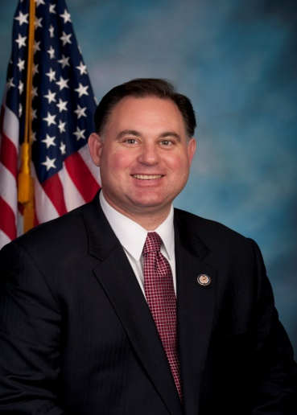

Congressman Frank Guinta


Dear Disabled American Veteran,
One of the most important responsibilities of our federal government is to provide our men and women in uniform the support they need to accomplish their mission, as well as the support they need when they return home. Our liberties, values, and everything America stands for is due to the heroic service and sacrifice of our nation’s disabled veterans.
My office and staff are ready to serve you. Please do not hesitate to call or visit my office if you have questions or need assistance regarding your VA benefits, Social Security, obtaining medals earned or military records, obtaining a flag flown over our nation’s capitol, or a letter for special recognitions and events.
My veterans’ liaison and staff are also available to meet with members of your post to assist you in person. I want to be a strong advocate and voice for our veterans, not only in Washington, but here in New Hampshire.
If you need assistance in any federal matter, please do not hesitate to contact my veterans’ liaison, David Tille at (603) 641-9536 or david.tille@mail.house.gov or visit my District Office on 33 Lowell Street in Manchester, New Hampshire.
Thank you for your patriotic service to our country. It is an honor to serve you in the U.S. House of Representatives.

Sincerely,
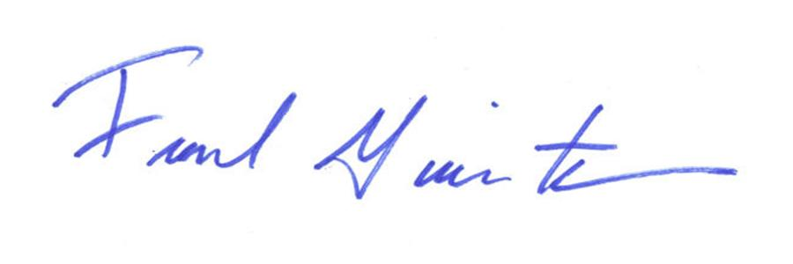
Frank C. Guinta
Member of Congress

Committee Assignments:

Budget

Oversight and Government Reform
Government Organization, Efficiency and Financial Management
Regulatory Affairs, Stimulus Oversight and Government Spending

TARP
Financial Services and Bailouts of Public and Private Programs (Vice Chair)

Transportation and Infrastructure
Aviation
Coast Guard and Maritime Transportation
Highways and Transit

Leadership and management Organizations
Republican Freshman Class of the 112th Congress
Republican Study committee

Washington Office

1223Longworth House Office Building
Washington, DC 20515-2901
Tel. 202.225.5456.225.5822
Fax. 202.225.5822

Manchester Office

33 Lowell Street
Manchester, NH 03101
Tel. 603-641.9536
Fax. 603.641.9561
David E. Tille
Senior Project Officer and Veterans’ Liaison
david.tille@mailhouse.gov

Congressman Charles F. Bass
Charles F. Bass was elected to represent New Hampshire's Second Congressional District in November 2010. The Second District covers the western half of the state, stretching from the Merrimack Valley west to the Monadnock Region, and north to the Upper Valley and the Canadian border.
Bass has a long record of public service in New Hampshire. He previously represented the Second Congressional District from 1995 to 2007 and championed a number of initiatives important to the people of New Hampshire, including expanding broadband access to rural communities, preserving New Hampshire's scenic environment, and promoting clean, alternative energies that will lessen our dependence on foreign sources of oil. In the 112th Congress, Bass was appointed to serve on the House Energy and Commerce Committee, allowing him to effectively represent the needs of the Granite State.
Having managed and built a successful architectural products firm in New Hampshire, Bass understands firsthand the financial and regulatory burdens that many small businesses face in today's economy. Bass strongly supports policies to keep taxes low and spending in check so that businesses, and not the federal government, can create jobs and grow our economy. He also opposes efforts to create a government-run health care system and supports market- and patient-based policies that will improve affordability and accessibility while allowing Americans to retain control over their health care decisions.
Bass also recognizes that the federal government must learn to live within its means. That's why he is a cosponsor of legislation to balance the budget, and supports measures to cut out-of-control federal spending.
Prior to being re-elected to Congress in 2010, Bass served on the Board of Managers at New England Wood Pellet in Jaffrey, one of the leading producers of clean-burning wood pellets, and was a senior advisor to Laidlaw Energy Group, a company that initiated the project to convert the former Fraser Pulp and Paper site in Berlin to a clean, wood-chip burning energy plant.
Early in his public service career, Bass served in the New Hampshire Legislature as a State Senator for two terms, and before that, as a State Representative. After graduating from Dartmouth College with a Bachelor of Arts degree in 1974, Bass worked for former Maine Reps. William Cohen and David Emery.
Bass lives in Peterborough with his wife Lisa and their two children, Lucy and Jonathan. He enjoys skiing, hiking, rebuilding old cars in his barn, and spending time with his family.
Committees and Caucuses

Member, House Energy and Commerce Committee http://energycommerce.house.gov/)
-- Subcommittee on Communications and Technology
-- Subcommittee on Environment and Economy
-- Subcommittee on Commerce, Manufacturing and Trade
Caucus Memberships:
-- Congressional Arts Caucus
-- Congressional Sportsmen's Caucus
-- General Aviation Caucus
-- House Veterans Caucus
-- Congressional Biomass Caucus (co-chair)

New Hampshire Second District
New Hampshire's Second Congressional District covers the western half of the state, stretching from the Merrimack Valley in the south, west to the Monadnock Region, and north to the Upper Valley and the Canadian border. It includes all of Coos, Grafton, Sullivan, and Cheshire Counties, and parts of Hillsborough, Merrimack, Belknap, and Rockingham Counties. The nearly 180 towns, cities, and locations in the Second District help to make the Granite State truly unique.
Offices:

Washington Office

2350 Rayburn HOB
Washington, DC 20515-2902
Tel (202) 225-5206
Fax (202) 225-2946

Concord Office Nashua Office Littleton Office

114 North Main Street, Suite 200 221 Main Street, Suite 201 32 Main Street, Room 110
Concord, NH 03301 Nashua, NH 03060 Littleton, NH 03561
Phone: 603-226-0064 Phone: 603-595- Phone: 603-444-5505
Fax: 603-226-0085 Fax: 603-595-77 Fax: 603-444-5505
Hours: M–F 0900-1700 Hours: M-F 0900-1700 Hours: M&F 0900-1700
T-Th by appointment

