The Sioux Falls Area Veterans Council

Veteran of the Year Award

The Sioux Falls Area Veterans Council annually recognizes up to four veterans who have, throughout the year, presented themselves as an outstanding example of a Veteran, and have demonstrated by action and example a concern for the lives and improvement thereof of fellow brothers and sisters formerly under arms to The United States of America in the Sioux Falls Area.
The Council's Award Selection Committee will be conside1ing a nominee's:
I. Membership in Veterans Organizations
- Participation in Veterans Organizations, their activities and programs
- Community involvement, organizations and activities other than veteran
- Volunteerism and outreach
- Veterans advocacy and efforts on behalf of Veterans that are not job related
- Military record, accomplishments, recognition and circumstances of service.
The award will be presented at the annual Sioux Falls Community Veterans Day Ceremony November 11. No posthumous awards will be given.

A recipient of the Veteran of the Year Award may not be again eligible to receive the award for a period often (10) years.
A nominee need not be a member of any veteran's organization, however, all nominations must be on the approved application and must be submitted by a voting member organization of The Sioux Falls Area Veterans Council.
Further, the completed application MUST;
- Be signed by an executive officer of the submitting member organization
- Have the DD 214 of the nominee attached
- Be received by the Sioux Falls Area Veterans Council c/o VFW, 3601 S. Minnesota Ave, Sioux Falls, SD 57105 no later than:
- 6:00 pm September 17th.

Appendix C
Veteran of the Year Application

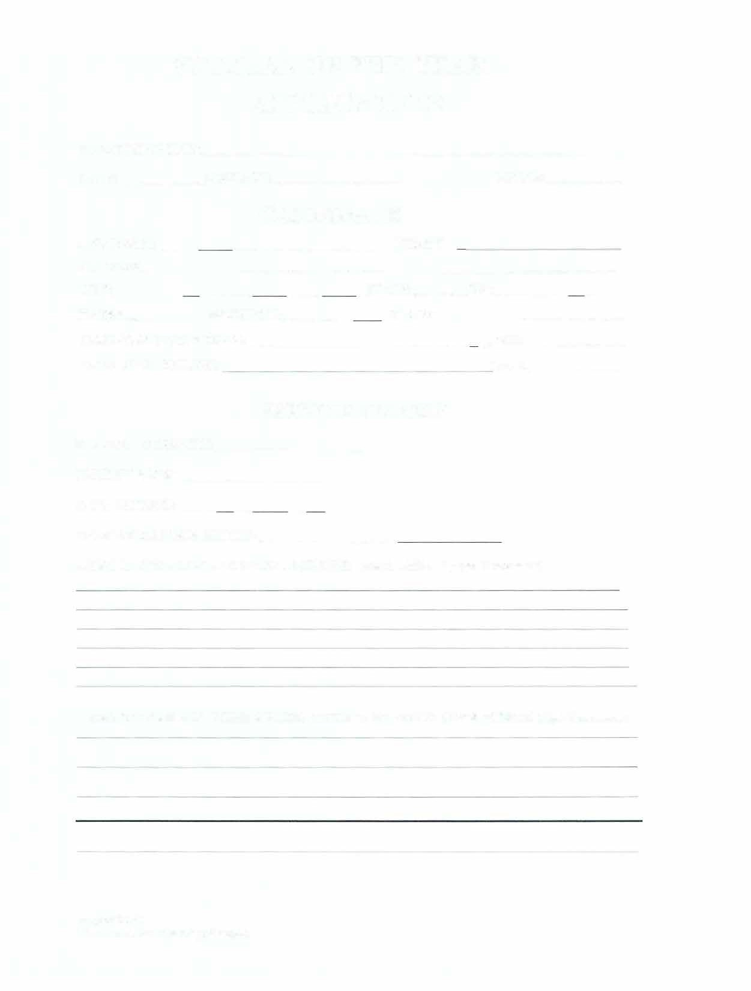
VETERAN OF THE YEAR APPLICATION
SUBMITTING UNIT:
DATE: -�---CONTACT: PHONE:
CANDIDATE
LAST NAME: FIRST:
ADDRESS:
CITY: _STATE: ZIP: _ PHONE: __ _BIRTH DATE: � PLACE: NAME GRAD HIGH SCHOOL: _,DATE:_ NAME GRAD COLLEGE: DATE:-----

SERVICE RECORD
BRANCH OF SERVICE:

HIGHEST RANK: __ DATE ENTERED:-- - -
DATE DISCHARGED/ RETIRED: �----- ­

AREAS OF OPERATION AND SPECIAL MISSIONS: (Attach additional pages ifnecessary)

DECORATIONS AND OTHER AWARDS WHJLE IN MILITARY: (Attach additional pages if necessary)

Appendix C
Veteran of the Year Application

COMMUNITY INVOLVEMENT

SPOUSE: DATEMARJED _

CHILDREN: MEMBER OF ORGANIZATIONS OTHER THAN VETERAN GROUPS. INCLUDE YEARS OF MEMBERSHJP:

ACTIVITY INVOLVEMENT: INCLUDE TOTAL NUMBER OF HOURS AND YEARS OF VOLUNTEER TIME:

AWARDS: ---

OTHER COMMENTS:

Appendix C
Veteran of the Year Application

VETERAN PARTICIPATION

VETERAN ORGANIZATIONS INCLUDE YEAR JOINED

POSITIONS ELECTED OR APPOINTED TO (NATIONAL, STATE OR LOCAL) INCLUDE VEAR

TIME SPRNDT HELPING VETERANS (give total hours for each type of volunteer work).

AWARDS FOR HELPING VETERANS (give year, if from local or state):

OTHER COMMENTS: ----

APPROVING OFFICER: DATE: _

Appendix C
Veteran of the Year Application

SFAVC VETERAN OF THE YEAR AWARD SELECTION SHEET

NAME OF VETERAN:


YBIBB AN'$ SEBYTCE BBCQBD

Exceptionalism veteran's career Difficulty of service
Overall impression of service record blatant branch favoritism

1-10
1-10

I-10
1-4

SERVICE RECORD TOTAL

VETERAN'S ORGANIZATIONS

Number of groups Involvement, committees Elected or appointed office Volunteerism for organization
Participation in organization activities
1-10

1-10

1-10

1- 10

1-10

VETERAN'S ORGANIZATIONS TOTAL

COMMUNITY INVOLVEMENT

Number of groups | 1-10
Involvement, committees | 1-10
Elected or appointed office | 1- IO
Volunteerism for organization | 1-10
Participation in organization activities | 1-10
Awards, exceptional services | 1-10

COMMUNITY INVOLVEMENT TOTAL

SIOUX FALLS AREA VETERANS COUNCIL VETERAN OF THE YEAR APP
VIETNAM VETERANS OF AMERICA CHAPTER 959 VETERANS OF FOREIGN WARS 628
VETERANS OF FOREIGN WARS 4726 DISABLED AMERICAN VETERANS PARALYZED VETERANS OF AMERICA AMERICAN LEGION POST #15 AMERICAN LEGION POST #318
MILITARY ORDER OF THE PURPLE HEART MARINE CORPS LEAGUE
NAVY CHIEFS ROLLING THUNDER
MILTARY OFFICERS ASSOCIATION OF AMERICA LEGION OF HONOR
WARRIORS NEVER GIVE UP

Appendix C
Veteran of the Year Application

