TO: DEPARTMENT OFFICERS, DEC, CHAPTERS, AND AUXILIARY UNITS

FROM: CHRISTINE SPEIRS, COMMANDER AND MARTY PENNOCK, ADJUTANT

SUBJECT: JUNE 2023 DAV MONTHLY REPORT

DATE: JUNE 1st, 2023

INFORMATION CONTAINED IN THIS MONTHLY REPORT IS TO BE PRESENTED AT YOUR MONTHLY MEETING EITHER BY THE DEC REPRESENTATIVE OR ADJUTANT. YOU SHOULD TRY TO HIGHLIGHT EACH OF THESE ARTICLES FOR YOUR MEMBERSHIP MEETING. YOU MAY USE ANY OF THESE ARTICLES FOR YOUR CHAPTER NEWSLETTER.

1. POPULATION SUMMARY: Life membership discount running June 1st, 2023 – March 31st, 2024.
- Attached New Program Flyer
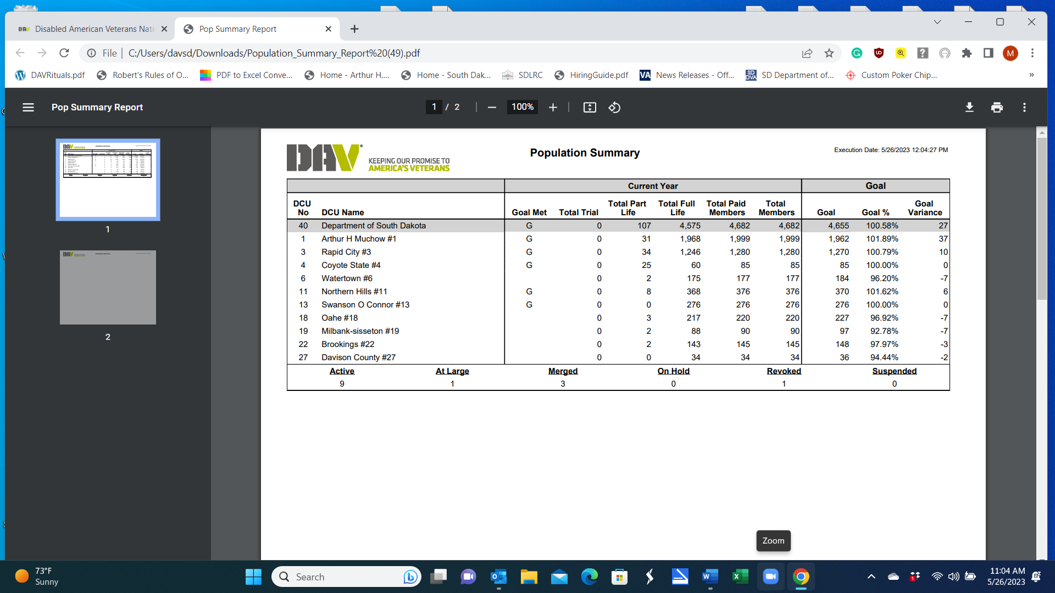

2. SOUTH DAKOTA VETERANS COUNCIL: The next SDVC meeting will take place July 19th, 2023, in Sisseton, venue still to be determined. The meeting will run from 11am to 2pm (CST).
3. DAV HOSPITAL TRANSPORTATION NETWORK: The 2022-2023 DAV Transportation Network and Columbia Trust Grant Application was submitted for an Explorer 4WD, in Winner. This has been approved.

4. DAV AND AUXILIARY 2023 ANNUAL DEPARTMENT OF SD CONVENTION:
Chapter 1 hosted the 2023 DAV Department and Auxiliary State Convention, May 5th - 6th, 2023. The Delegate and Alternate list were signed by the Commander and Adjutant sent to National. Attached are the following for review.
- DAV Department Convention Raffle and Challenge Coin Funds
- 2023 DAV Department of SD Raffle Winner List
- DAV Department of SD Committee Assignment List
- DAV Department of SD Officer Lists
- Media Announcement on DAV Department of SD Convention
Delinquent Reports, Upcoming Suspense and Return Ballots from the Convention include.
- DEC Minutes of May 5th – Pending Approval of DEC by June 9th, 2023
- Minutes DAV Dept. of SD Convention Business Sessions – May 5th - 6th – Pending Approval of DEC by June 9th, 2023
- DEC Minutes of May 6th – Pending Approval of DEC by June 9th, 2023
- DEC Assignments from Oahe Chapter Number 18
- DEC Assignments from Milbank Chapter Number 19
- DEC Assignments from Davison County Chapter Number 27
- Resolution Committee Must File Dept. of SD Resolutions to National by July 22nd, 2023
- Department Policies That Were Handed Out at the Department Convention – To Date- None Have Been Returned - attached

5. 2023 NATIONAL CONVENTION: AUGUST 3rd – 9th, 2023(Includes Travel and Dis. 14 MTG)
All travel reimbursement to this event will be the responsibility of individual Chapters.
Harrah’s Atlantic City
777 Harrah’s Blvd.
Atlantic City, NJ 084011
$149 Single / Double
Phone: 888-516-2215 (8am-2am EST, 7 days a week)
Group name: DAV 2023 National Convention
Group code: SH07DV3 (code -- “DAV 2023 National Conv”)
6. SDDVA ANNUAL BENEFIT SCHOOL
The SDDVA annual benefit school will be held in Sioux Falls September 5th -7th, 2023.
The training will be held at the SD Military Heritage Alliance (1600 W. Russell Street).
Lodging has been secured at the Sheraton (1211 N. West Avenue). The Sheraton will be honoring the $75 state rate. Ask for the South Dakota Department of Veterans Affairs block of rooms. Room block is only open until August 7th, 2023.
Adjutant Pennock received the following list of members attending the event. No other members are allowed to attend the event for the DAV. Travel reimbursement to this, is the Chapters’ responsibility.
- Margaret (Peggy) Kirk
- Dick Turnwall
- Ed Simpson
- John Price
- Dennis Cutschall
- Christine Speirs
- Mark Wolf
- Tim Walsh
- Dave Van Dine
- Kim Hubers

TENATIVE AGENDA

Tuesday – September 5th

1:00 pm Introductions
Brief SDDVA Update
1:15 pm VA Public Contacts
2:00 pm Caregiver Program
3:00 pm Break
3:15 pm Nursing Home/Hospice Program
4:00 pm MST
5:00 pm Adjourn

Wednesday – September 6th

8:00 am Hands on Tyler Training
Noon Sponsored Luncheon
1:00 pm Hands on Tyler Training
2:00 pm Case Scenarios – Using Tyler packaging
3:00 pm Travel State SD Veterans Cemetery

Thursday – September 7th

8:00 am Prosthetics
9:00 am Hearing Loss and Memory Loss
10:00 am Break
10:15 am Cornerstone Mission
11:00 am Eligibility
Noon Sponsored Luncheon/Awards Ceremony
1:30 pm Claims Processing
2:30 pm Test

7. DAV SOUTH DAKOTA FALL CONFERENCE: The date has been set for October 7th, 2023, at the DAV Home, in Sioux Falls, SD. A Commander’s reception will take place on the night of October 6th, 2023. Travel reimbursement to this event will be on individual Chapters. Lodging is available at the following $159.00 until September 22nd, 2023

Comfort Inn & Suites Avera Southwest
3721 W. Avera Drive, Sioux Falls, SD, 57108, US
(605) 593-0768

8. DAV 14TH DISTRICT FALL CONFERENCE: Kallispell, MT, October 14th – 15th. More information will follow the DAV Department of Montana Convention June 2-3, 2023. Department Commander Christine Speirs will be representing the DAV Department of SD. If Chapters wish to attend, please let the DAV HQ know. Travel reimbursement to this event will be on individual Chapters.

9.OTHER INFORMATION:
- Northern Hills Veterans Appreciation Fair – Saturday, November 4th, 2023 – Sturgis
- DAV Information Seminar – June 20th, 2023 – Deadwood
- DAV Information Seminar – June 21st, 2023 – Rapid City
- DAV Announces National Leadership Change
- DAV Scholarships
- Rounds Make Third Attempt at Congressional Charter for Native American Veterans
- Rounds, Lujan and Johnson Introduce National American Indian Veterans Charter Bill
- Call Your Senator(s) Today & Tell Them to Vote Yes on S. 326, the Elizabeth Dole Veterans Programs Improvement Act of 2023
- S. 1360 – the PFAS Exposure Assessment and Documentation Act
- S. 1266 – the Love Lives on Act
- S. 326 Elizabeth Dole Veterans Programs Improvement Act of 2023
- H.R. 2414 / S. 1119, the CHAMPVA Children’s Care Protection Act of 2023
- H.R. 1606 – the Veterans Entrepreneurship Training Act
- S. 928, the Not Just a Number Act
- H.R. 1799, the EMPLOY VETS Act
- Information Alert – April 28, 2023
- H.R. 693, the VACANT Act
- H.R. 542, the Elizabeth Dole Home Care Act
- H.R. 808, the Veterans Patient Advocacy Act
- S. 414 / H.R. 1083 – Caring for Survivors Act of 2023
- S. 344 & H.R. 1282 – The Major Richard Star Act
- H.R. 1278 / S. 592 – the DRIVE Act
- H.R. 1529 / S. 777 – the Veterans’ Compensation Cost-of-Living Adjustment (COLA) Act of 2023
- S. 132 – the Daniel J. Harvey Jr. and Adam Lambert Improving Servicemember Transition to Reduce Veteran Suicide Act
- H.R. 411 – the Lead by Example Act of 2023
- H.R. 333 – the Disabled Veterans Tax Termination Act
- How Veterans Benefits Could be Delayed in June by a US Default
- Budget Cut Proposals Would Hurt Veterans

10. DIRECT DEPOSIT FOR DAV EMPLOYEES: Research has been conducted on the cost associated with providing paid employees reimbursement via direct deposit into individual bank accounts. The fees associated with this are very limited and should be under $25.00 per month. The DAV Staff will be coordinating with First Interstate Bank to secure this pay process and make it operational by the end of June 2023.

11. DAV DEPARTMENT BULLETIN DEADLINE: July 2023 BULLETIN: Submittal deadline: June 10th. Email all reports, photos, stories to: adj@davsd.org.

Department Officers, Chapters, Auxiliary State Officers, and Auxiliary Units who wish to place an article in DAV Department of South Dakota Quarterly Bulletin should submit them by the deadline date – stated below. The DAV Department Officers ARE RESPONSIBLE for submitting their own articles.

12. DAV DEPARTMENT OF SOUTH DAKOTA QUARTERLY BULLETIN & MONTHLY REPORT:
If any of the DAV and Auxiliary members would like to receive the DAV Department Quarterly Bulletin and Monthly Report, please send your e-mail address to DAV Headquarters:

NAME: ___________________________
PHONE: __________________________
E-MAIL: __________________________

You can either mail or e-mail the information to:
DAV Headquarters, 1519 W. 51st Street, Sioux Falls, SD 57105
E-mail: admin@davsd.org

