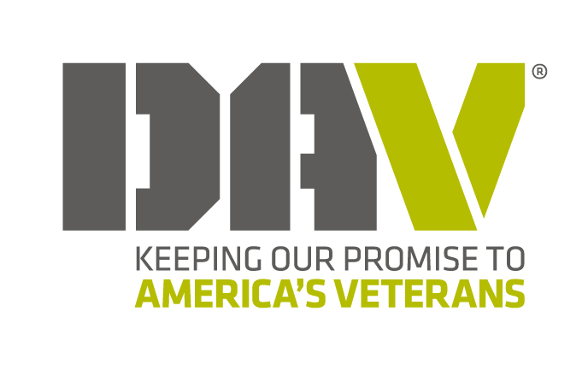

**TENTATIVE: As of Feb. 28, 2025**

**2025 CONVENTION SCHEDULE**

**Disabled American Veterans Department of Wisconsin**

**96th Annual Department Convention**

Oneida Hotel & Conference Center – Green Bay, WI June 12th - 14th

**THURSDAY, JUNE 12th**

10:00 AM - 3:00 PM Registration **Outside Great Lakes**

Noon Foundation

All Thursday Committee Meetings in the Wolf Room

12:30 PM Transportation

1:00 PM Women Veterans Advisory Cmte..

1:30 PM Media Committee

2:00 PM Hospital & Rehab

2:45 PM Finance Committee*

3:30 PM Executive Committee*

**\*These meetings may conclude with a Closed Session for Personnel Issues.**

**National Service Officer Informational Session**

**Oneida Room 1:00-3:00**

**Friday, June 13th**

  6:00-8:00 PM Commander's Hospitality **Plaza Club**

**FRIDAY, JUNE 13th**

7:30-11:00 AM Registration **3 Clans Prefunction Area**

8:00-Noon Joint Session – Guest Speakers

All Friday Business Sessions in the Wolf Room

10:20 AM Break - Kringle from Chapter 3

12:00-1:30 PM Past Cmdrs Lunch – **Grand Ballroom**

12:00-1:30 PM Registration

1:30-3:00 PM Business Session 1

2:30 PM Break, if necessary,

3:00 PM Business Session 2

5:00 PM - Dinner at 6:00 - Auxiliary Hospitality **Turtle/Bear**

**SATURDAY, JUNE 14th**

7:30-11:00 AM Registration **3 Clans Prefunction Area**

7:00 AM Nominating Committee **Executive Board Room**

7:30 AM Memorial **Tuscarora/Oneida**

8:00 AM Business Session 2 (Cont.)

All Saturday Business Sessions in the Wolf Room

10:00 AM Break

10:30 AM Business Session 3

12:00-1:30 PM Commander’s Lunch by invite - **Turtle**

1:40 PM Business Session 3 (Cont.)

2:30 PM Break

3:00 PM Business Session 4 (Reports)

4:00 PM Election of Officers for 2023-2024

4:30 PM Installation of Officers

4:45 PM Convention Ends **Adjournment by New Commander**

5:30-6:15 PM Cocktails - Cash Bar **Turtle/Bear**

6:15 PM Commander’s Reception **Turtle/Bear**

**SUNDAY, JUNE 15th**

8:30-11:30 AM Finance & Executive Meetings **Huron/Ontario**

**FUTURE EVENTS: Fall Conference – October 15-17, 2025 – Stevens Point**

**State Convention – June 11-13, 2026 – Green Bay**

**Fall Conference – October 28-30, 2026 – La Crosse**